SIMATS ENGINEERING (SAVEETHA SCHOOL OF ENGINEERING)
Department of Computer Science and Engineering
CO4 ASSESSMENT TOOL 1 – Test Case Design Assignment

Course Code: | CSA10 / CSA1007 | Course Title: | Software Engineering
CO Assessed: | CO4 | Assessment: | Assessment Tool 1 – Test Case Design Assignment
Weightage: | 20% | Total Marks: | 25
CO4 Statement: | Implement robust testing, quality assurance, and DevOps practices, emphasizing security, reliability, and ethics
Student Name: | P ROHINI | Reg. No.: | 192524147
Date: | 25-08-2026 | Duration: | 60 minutes

Code of Conduct
I P ROHINI (192524147) (Name / Reg No) certify that this submission is my original work and that I have adhered to the guidelines specified for this assessment. I understand that any violation of academic integrity rules will result in disciplinary action.
Signature of the Student: P ROHINI
Annexure A – Test Case Design Assignment
Instructions to Students:
Each student is assigned an individual problem statement. Based on the assigned problem statement, design and document comprehensive test cases to verify the correctness, functionality, reliability, and usability of the proposed system.
Your test case design should include:
- Identify the functional and non-functional requirements to be tested.
- Identify the test scenarios for the assigned problem statement.
- Prepare detailed test cases covering normal, boundary, invalid, and exceptional conditions.
- Include Test Case ID, Test Scenario, Test Steps, Test Data, Expected Result, Actual Result, and Pass/Fail Status.
- Apply appropriate test design techniques such as Equivalence Partitioning, Boundary Value Analysis, Decision Table, or State Transition Testing wherever applicable.
- Ensure that the test cases provide adequate requirement and functional coverage for the assigned system.
Deliverable: Submit a Test Case Design document containing the identified scenarios, test cases, test data, expected results, and test coverage based on the individual problem statement.

Rubrics for Calculation
Evaluation Criteria | Excellent (4 Marks) | Good (3 Marks) | Satisfactory (2 Marks) | Needs Improvement (1 Mark)
Requirement & Test Scenario Identification(15%) | Clearly identifies all relevant functional/non-functional requirements and comprehensive test scenarios | Identifies most requirements and scenarios | Identifies basic requirements and scenarios | Requirements/scenarios are incomplete or unclear
Test Case Design & Completeness(25%) | Comprehensive test cases covering normal, boundary, invalid, and exceptional conditions | Covers most important conditions with minor gaps | Covers basic conditions but misses several important cases | Test cases are very limited or incomplete
Test Data & Expected Results(20%) | Appropriate test data with precise, measurable expected results for every test case | Mostly appropriate test data and expected results | Some test data/results are unclear or incomplete | Test data and expected results are largely missing/incorrect
Application of Test Design Techniques(15%) | Correctly applies multiple techniques such as Equivalence Partitioning, Boundary Value Analysis, Decision Table, and State Transition | Correctly applies at least two relevant techniques | Applies one technique with limited justification | Techniques are not applied or incorrectly applied
Traceability & Test Coverage(15%) | Excellent mapping between requirements, scenarios, and test cases with strong coverage | Good traceability and coverage with minor gaps | Partial traceability and moderate coverage | Poor/no traceability and inadequate coverage
Documentation & Presentation(10%) | Well-structured, clear, professional, consistent, and easy to understand | Well-organized with minor presentation issues | Adequately organized but has some clarity/formatting issues | Poorly organized, unclear, or incomplete documentation

Criteria | Mark
Requirement & Test Scenario Identification (15%) | /5
Test Case Design & Completeness (25%) | /4
Test Data & Expected Results (20%) | /4
Application of Test Design Techniques (15%) | /4
Traceability & Test Coverage (15%) | /4
Documentation & Presentation (10%) | /4
TOTAL | /25

CO4-ASSISSMENT TOOL-1

COURSE CODE: CSA1007
COURSE NAME: SOFTWARE ENGINEERING
NAME: P ROHINI
REG NO: 192524147

35) Smart Urban Traffic Congestion Prediction and Signal Optimization Platform
Industry Context
The transportation sector is rapidly adopting digital technologies to improve efficiency, safety, scalability, and decision making. Traditional approaches often rely on manual processes and reactive monitoring, resulting in delays, increased operational costs, resource wastage, and reduced service quality. There is a growing need for an intelligent, cloud-enabled, distributed platform capable of collecting real-time IoT and enterprise data, analyzing operational conditions, predicting risks, and supporting timely interventions.
Problem Statement
Design and develop a distributed Smart Urban Traffic Congestion Prediction and Signal Optimization Platform that continuously acquires real-time operational data from connected devices, enterprise systems, and users. The platform should detect abnormal events, generate predictive insights using AI/ML, notify stakeholders in real time, provide centralized dashboards, generate reports, and support secure, scalable, fault-tolerant operation across multiple locations.

Objectives
• Collect real-time operational data.
• Monitor system performance continuously.
• Detect anomalies automatically.
• Predict failures or risks using analytics.
• Notify stakeholders immediately.
• Generate dashboards and reports.

Test Case Design Assignment

Project Title:
Smart Urban Traffic Congestion Prediction and Signal Optimization Platform

1. Functional and Non-Functional Requirements
Functional Requirements:

ID | Requirement
FR01 | Collect real-time traffic data
FR02 | Monitor traffic conditions
FR03 | Detect abnormal traffic conditions
FR04 | Predict traffic congestion
FR05 | Optimize traffic signals
FR06 | Send alerts to stakeholders
FR07 | Display traffic information on dashboard
FR08 | Generate traffic reports

Non-Functional Requirements:

ID | Requirement
NFR01 | System should respond quickly
NFR02 | System should be reliable
NFR03 | System should provide secure access
NFR04 | System should support multiple locations
NFR05 | System should be easy to use
NFR06 | System should handle increasing traffic data

2. Test Scenarios
The following scenarios are identified for the traffic management platform:

Scenario ID | Test Scenario
TS01 | Verify traffic data collection
TS02 | Verify traffic monitoring
TS03 | Verify abnormal traffic detection
TS04 | Verify congestion prediction
TS05 | Verify traffic signal optimization
TS06 | Verify alert notification
TS07 | Verify dashboard display
TS08 | Verify report generation
TS09 | Verify invalid traffic data handling
TS10 | Verify system response during high data load
TS11 | Verify secure user access
TS12 | Verify system recovery after failure

3. Detailed Test Cases
The file requires each test case to contain Test Case ID, Test Scenario, Test Steps, Test Data, Expected Result, Actual Result, and Pass/Fail Status.

ID | Test Scenario | Test Steps | Test Data | Expected Result | Actual Result | Status
TC01 | Traffic data collection | Send valid traffic data | Vehicle count = 50 | Data should be collected successfully | Data collected | Pass
TC02 | Traffic monitoring | Open dashboard | Traffic = Normal | Current traffic status should be displayed | Status displayed | Pass
TC03 | Abnormal traffic detection | Enter very high traffic value | Vehicle count = 500 | System should detect abnormal traffic | Abnormal condition detected | Pass
TC04 | Congestion prediction | Submit traffic data | Density = High | System should predict congestion | Congestion predicted | Pass
TC05 | Signal optimization | Submit high traffic condition | High traffic | Signal timing should be optimized | Signal updated | Pass
TC06 | Alert notification | Generate congestion condition | Congestion = High | Alert should be sent | Alert generated | Pass
TC07 | Dashboard display | Open dashboard | Current traffic data | Data should be displayed correctly | Data displayed | Pass
TC08 | Report generation | Select report option | Daily traffic data | Report should be generated | Report generated | Pass
TC09 | Invalid data | Enter invalid vehicle count | -10 | System should reject invalid data | Invalid data rejected | Pass
TC10 | Empty input | Submit without traffic data | Blank | Validation message should appear | Message displayed | Pass
TC11 | User authentication | Enter valid login details | Valid username/password | User should be logged in | Login successful | Pass
TC12 | Invalid login | Enter incorrect credentials | Wrong password | Access should be denied | Access denied | Pass
TC13 | High data load | Send multiple traffic records | Large data set | System should continue processing | System processed data | Pass
TC14 | Database failure | Disconnect database | Database unavailable | System should show appropriate error | Error displayed | Pass
TC15 | Report with no data | Request report without records | Empty dataset | System should show no-data message | Message displayed | Pass

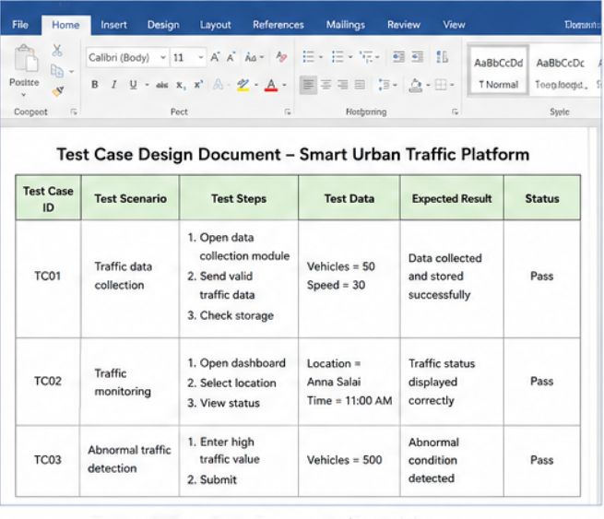

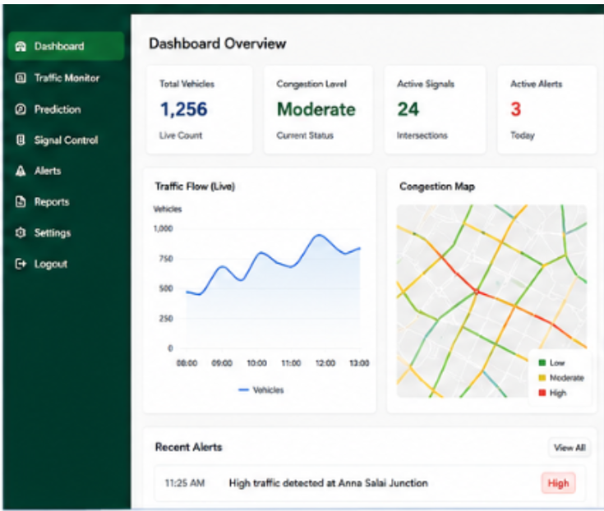

4. Test Design Techniques
The assignment requires suitable techniques such as Equivalence Partitioning, Boundary Value Analysis, Decision Table, and State Transition Testing.
Equivalence Partitioning:
Traffic vehicle count can be divided into valid and invalid groups.

Input | Class
0 or more | Valid
Negative number | Invalid
Text value | Invalid

Example:
50 → Valid
-10 → Invalid
ABC → Invalid

Boundary Value Analysis:
For vehicle count:
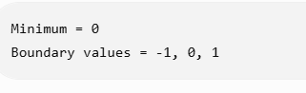

Test:
- -1 → Invalid
- 0 → Valid
- 1 → Valid
This verifies the system near the input boundary.

Decision Table:
For traffic congestion:

Traffic Density | Abnormal Condition | Congestion | Action
Low | No | No | Normal signal
Medium | No | No | Normal signal
High | No | Yes | Optimize signal
High | Yes | Yes | Optimize signal + Alert

State Transition Testing
Traffic signal states can be:

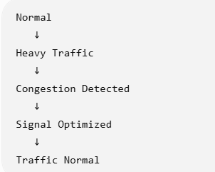

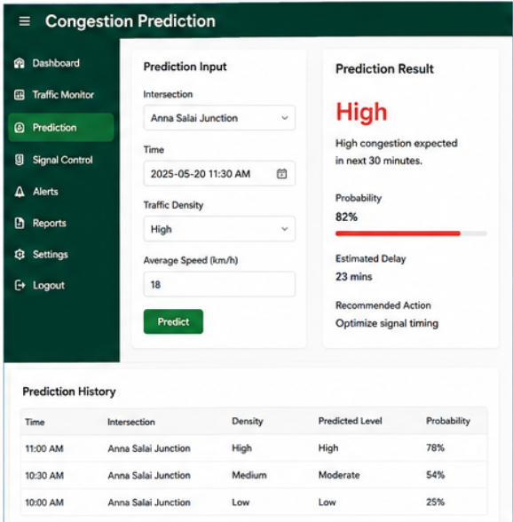

5.Traceability and Test Coverage:
The test cases are mapped to the functional requirements.

Requirement | Test Cases | Coverage
FR01 Data Collection | TC01 | Covered
FR02 Monitoring | TC02 | Covered
FR03 Anomaly Detection | TC03 | Covered
FR04 Prediction | TC04 | Covered
FR05 Signal Optimization | TC05 | Covered
FR06 Alerts | TC06 | Covered
FR07 Dashboard | TC07 | Covered
FR08 Reports | TC08, TC15 | Covered
NFR01 Performance | TC13 | Covered
NFR03 Security | TC11, TC12 | Covered
NFR02 Reliability | TC14 | Covered
This provides traceability between requirements → test scenarios → test cases. The rubric gives importance to strong requirement and test coverage.

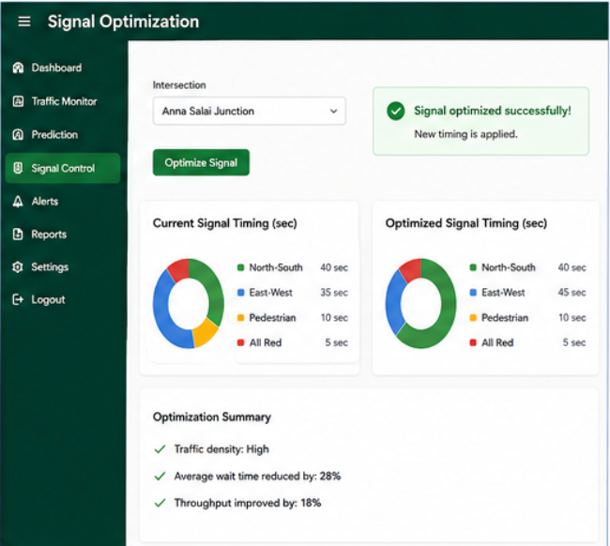
6.Test Case Summary:
The test cases cover:
- Normal conditions – TC01–TC08
- Boundary conditions – Boundary Value Analysis
- Invalid conditions – TC09, TC10, TC12
- Exceptional conditions – TC13, TC14, TC15
Therefore, the test design provides coverage for the major functional and non-functional requirements of the Smart Urban Traffic Platform.

7.Test Case Document Conclusion:
The designed test cases verify the correctness, functionality, reliability, security, and usability of the Smart Urban Traffic Congestion Prediction and Signal Optimization Platform. The test cases cover normal, boundary, invalid, and exceptional conditions. Different test design techniques are applied to improve the quality and coverage of testing.
The test case document therefore provides systematic validation of the proposed system and helps identify defects before deployment.

